# **Feature Scaling**

---

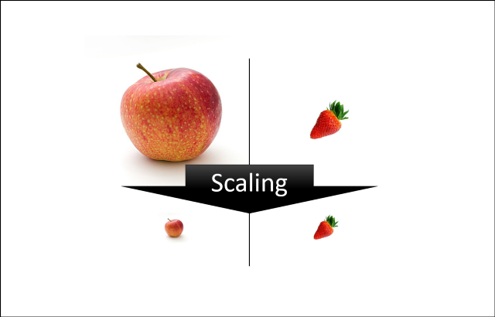

### **Why do we need scaling?**

Machine learning algorithm just sees number — if there is a vast difference in the range say few ranging in thousands and few ranging in the tens, and it makes the underlying assumption that higher ranging numbers have superiority of some sort. So, these more significant number starts playing a more decisive role while training the model.

Example: If an algorithm is not using the feature scaling method then it can consider the value 3000 meters to be greater than 5 km but that’s actually not true and, in this case, the algorithm will give wrong predictions. So, we use Feature Scaling to bring all values to the same magnitudes and thus, tackle this issue.

The machine learning algorithm works on numbers and does not know what that number represents. A weight of 10 grams and a price of 10 dollars represents completely two different things — which is a no brainer for humans, but for a model as a feature, it treats both as same.

Suppose we have two features of weight and price, as in the below table. The “Weight” cannot have a meaningful comparison with the “Price.” So the assumption algorithm makes that since “Weight” > “Price,” thus “Weight,” is more important than “Price.”

So, these more significant number starts playing a more decisive role while training the model. Thus, feature scaling is needed to bring every feature in the same footing without any upfront importance. Interestingly, if we convert the weight to “Kg,” then “Price” becomes dominant.

Another reason why feature scaling is applied is that few algorithms like Neural network gradient descent converge much faster with feature scaling than without it.

Some examples of algorithms where feature scaling matters are:

1. K-nearest neighbors (KNN) with a Euclidean distance measure is sensitive to magnitudes and hence should be scaled for all features to weigh in equally.
2. K-Means uses the Euclidean distance measure here feature scaling matters.
3. Scaling is critical while performing Principal Component Analysis (PCA). PCA tries to get the features with maximum variance, and the variance is high for high magnitude features and skews the PCA towards high magnitude features.
4. We can speed up gradient descent by scaling because θ descends quickly on small ranges and slowly on large ranges, and oscillates inefficiently down to the optimum when the variables are very uneven.

Algorithms that do not require normalization/scaling are the ones that rely on rules. They would not be affected by any monotonic transformations of the variables. Scaling is a monotonic transformation. Examples of algorithms in this category are all the tree-based algorithms — (1) CART, (2) Random Forests, (3) Gradient Boosted Decision Trees. These algorithms utilize rules (series of inequalities) and do not require normalization.

Algorithms like (4) Linear Discriminant Analysis (LDA), (5) Naive Bayes is by design equipped to handle this and give weights to the features accordingly. Performing features scaling in these algorithms may not have much effect.

**Normalization or Min Max Scaler:**

Transform features by scaling each feature to a given range. This estimator scales and translates each feature individually such that it is in the given range on the training set, e.g., between zero and one. This Scaler shrinks the data within the range of -1 to 1 if there are negative values. We can set the range like [0,1] or [0,5] or [-1,1].

This Scaler responds well if the standard deviation is small and when a distribution is not Gaussian. This Scaler is sensitive to outliers.

This is also known as Min-Max scaling. It scales the data to the range between 0 and 1. This scaling is performed based on the below formula.

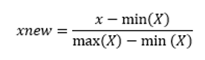

Where x is the current value to be scaled, min(X) is the minimum value in the list of values and max(X) is the maximum value in the list of values

Example: if X= [1,3,5,7,9] then min(X) = 1 and max(X) = 9 then scaled values would be:

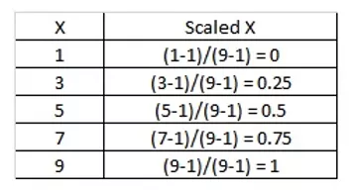

Here we can observe that the min(X) 1 is represented as 0 and max(X) 9 is represented as 1.

### **Standard Scaler:**

The Standard Scaler assumes data is normally distributed within each feature and scales them such that the distribution centered around 0, with a standard deviation of 1. Centering and scaling happen independently on each feature by computing the relevant statistics on the samples in the training set. If data is not normally distributed, this is not the best Scaler to use.

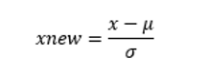

Where x is the current value to be scaled, µ is the mean of the list of values and σ is the standard deviation of the list of values.

The scaled values are distributed such that the mean of the values is 0 and the standard deviation is 1.

Example if X= [1,3,5,7,9] then

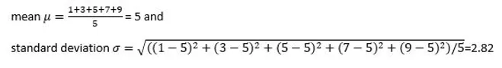

Then scaled values would be:

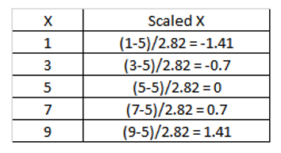

Here the values are ranging from -1.41 to 1.41. This range changes depending on the values of X.

### **Robust Scaler:**

As the name suggests, this Scaler is robust to outliers. If our data contains many outliers, scaling using the mean and standard deviation of the data won’t work well.

This Scaler removes the median and scales the data according to the quantile range (defaults to IQR: Interquartile Range). The IQR is the range between the 1st quartile (25th quantile) and the 3rd quartile (75th quantile). The centering and scaling statistics of this Scaler are based on percentiles and are therefore not influenced by a few numbers of huge marginal outliers. Note that the outliers themselves are still present in the transformed data. If a separate outlier clipping is desirable, a non-linear transformation is required.

### **Power Transformer Scaler:**

The power transformer is a family of parametric, monotonic transformations that are applied to make data more Gaussian-like. This is useful for modeling issues related to the variability of a variable that is unequal across the range (heteroscedasticity) or situations where normality is desired.

The power transform finds the optimal scaling factor in stabilizing variance and minimizing skewness through maximum likelihood estimation. Currently, Sklearn implementation of Power Transformer supports the Box-Cox transform and the Yeo-Johnson transform. The optimal parameter for stabilizing variance and minimizing skewness is estimated through maximum likelihood. Box-Cox requires input data to be strictly positive, while Yeo-Johnson supports both positive or negative data.